CENTRAL TO EVELEIGH (C2E) URBAN GROWTH NSW’S PROPOSED GROWTH CORRIDOR – NORTH EVELEIGH ISSUES July 2015
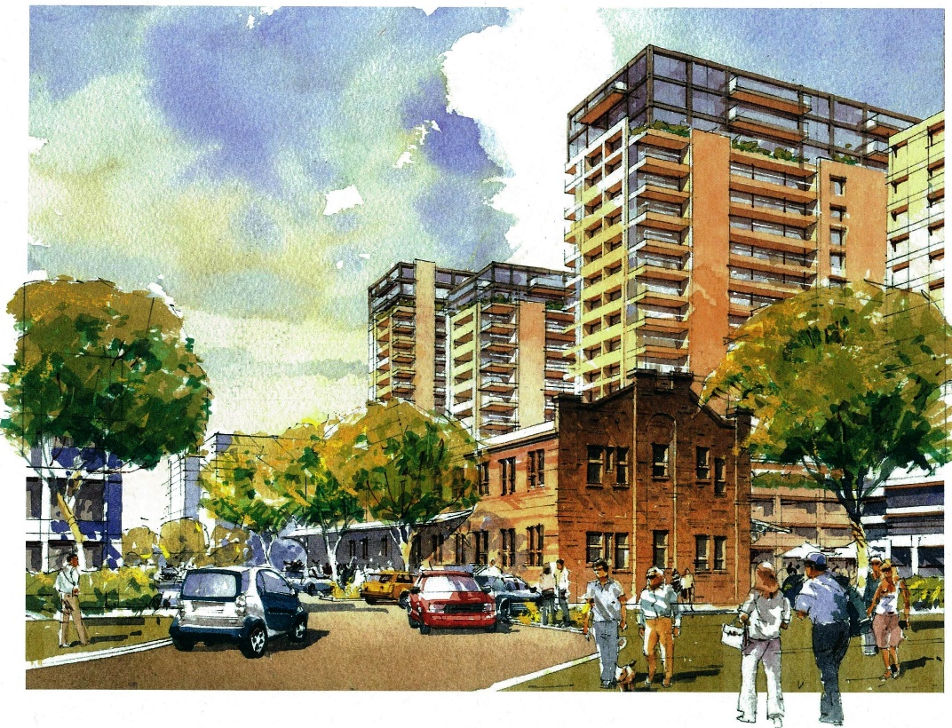
View of one proposal from the Wilson Street entry - the clothing store in the foreground.
HISTORY
The North Eveleigh site has been subject to a number of master plans over the last decade, including the North Eveleigh Master Plan.
- 2008: Frank Sartor promised a neighbourhood park at the western end of the site, seeking to finalise planning on this site.
- May 2012: Public Meeting unanimously resolved to ask for deferral of the Master Plan, which included buildings of up to 16 storeys, so that background studies could be conducted. These were:
(1) a comprehensive traffic study
(2) an urban design study of the public domain and the proposed park at the western end
(3) design of the buildings to demonstrate that they provided reasonable public and private amenity.
- 2012: the State Government ignores this resolution and adopts the Master Plan
- 2015: Urban Growth takes over development of the site in proposing a growth corridor from Central to Eveleigh, inserting in new buildings up to 50 storeys in height. This includes the redevelopment of the public housing estates in Redfern/Waterloo/Alexandria for a mix of private and social housing.
- May 30 2015: Urban Growth conducts a workshop in seeking to finalise its strategy for the corridor. This was attended by about 250 people, tabling various scenarios for mega development on this very constrained site, with only one uncontrolled intersection with Wilson Street. The image above is one scenario. We have a copies of them all if you want to take a look. Buildings step up to 22 storeys against the busiest rail line in Sydney.
Consultations close this Friday 10 July –It is most important that as many people as possible make a submission. Just sign and post the attached proforma or email us for an electronic copy.
Many thanks - Bruce & Sarah Lay - 210 Wilson cnr Queen (front door on Wilson). Happy to discuss or email you more information. lay.heritage@gmail.com
Email to c2e@urbangrowth.nsw.gov.au – by 10 July 2015
URBAN GROWTH NSW – SUBMISSION ON THE CENTRAL TO EVELEIGH CORRIDOR
NORTH NEWTOWN ISSUES
On 21 May 2012 a community meeting attended by about 250 people at The Carriageworks carried the following unanimous resolution:
‘That the North Eveleigh Master Plan be deferred for the preparation of the following background studies to guide appropriate development:
- A comprehensive traffic study of the network as well as the site to establish the best linkages particularly to the arterial system, as well as to achieve safety for pedestrians, cyclists and cars, and to establish truck routes particularly related to the construction phase and the servicing of The Carriageworks and the Rail network.
- An urban design study of the public domain including the new park to ensure compatibility with the local heritage values and streets, including responding to the issues raised by the City of Sydney.
- That plans be generated for the proposed buildings to ensure that they satisfy reasonable design and environmental standards’.

None of these studies has been done. The C2E starts from the assumption that it has been ‘adopted’. Therefore it is a real estate marketing not a planning document and it should be withdrawn. Proper consultation and technical studies need to be done. Otherwise it is a prelude to a planning disaster. UG did it better elsewhere in its previous guise of LANDCOM at Victoria Park Zetland, & in collaboration with the City at Green Square. A collaborative approach is essential to best outcomes.
Specific issues on the North Eveleigh site:
- The park committed in 2008 should be reinstated (about the size of Hollis Park)
- Buildings should be compatible with the local scale and character. This has already been breached by ‘The Platform’ affordable housing block (7 storeys). This should be a maximum height for the whole, with lower buildings along Wilson Street compatible with the existing.
- Traffic: the one uncontrolled access point for the anticipated 1000 additional cars, creates hazards to pedestrians and cyclists.
- Formerly there were promises of generous provision of affordable housing. This has not been committed and is likely to be whittled away. _______________________________________________________________________________________________________________________________________________________________________________________________________________________________________________________________________________________________________________________________________________________________________________________________________________________________________________________________________________________________________________________________________________________________________________________________________________________________________________________________________________________________________________________________________

Signed
Address

